**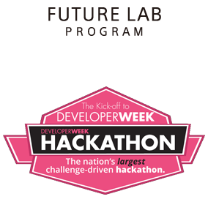**

**Setup and build a Nigel segment in 10 minutes**

**Step 1: Download and install the segment developer tools**

**https://developer.sony.com/develop/future-lab-program/n/get-started/**

Segment Developer Tools

The Segment Developer Tools app is a desktop application for testing and packaging segments.

**To download the Segment Developer Tools app and the sample segments:**

1. Go to the [developer page for N](https://developer.sony.com/develop/future-lab-program/n/n-developer-sign-up/" \t "_blank) : https://developer.sony.com/develop/future-lab-program/n/n-developer-sign-up/
2. Sign up for a developer account. If you already have a developer account, you’ll be required to sign in before downloading the Segment Developer Tools package.
3. Download the Segment Developer Tools package.
4. Unzip the appropriate Segment Developer Tools package for your OS: SegmentDeveloperTools-darwin-x64.zip or SegmentDeveloperTools-win32-ia32.zip.

**To set up the Segment Developer Tools app for the first time**

1. Install Node.js version 4.5 or greater from the [Node.js site](https://nodejs.org/en/" \t "_blank) : https://nodejs.org/en/
2. Open a terminal or command prompt.
3. Use the following command to confirm that your npm version is 2.15.9 or greater.

$ npm --version

1. If you are inside a private network, configure your npm proxy.

$ npm config set proxy $ npm config set https-proxy

1. Change the current directory to SegmentDeveloperTools.

$ cd SegmentDeveloperTools

1. Install the node modules for the Segment Developer Tools app.

$ npm install

1. Build the application.  
   This will create a **dist** directory that contains the app.

$ npm run build

**To run the Segment Developer Tools app**

1. Open the dist directory and launch the Segment Developer Tools app.

**Step 2: Create your first segment**

**https://developer.sony.com/develop/future-lab-program/n/how-to-create-your-first-segment/**

1. Copy the hello world segment from sample-segment\com.example.sony.da.hello to another directory
2. Rename the package to your custom package name :

* Rename your copied directory to com.yourname.firstapp
* Open com.yourname.firstapp/Manifest.json and rename the package to com.yourname.firstapp
* Open com.yourname.firstapp/defaultValues.json and rename the scope to com.yourname.firstapp
* Open com.yourname.firstapp/schema.json and rename the scope to com.yourname.firstapp

You now have your first segment

**Step 3: Load your segment in the emulator and test it**

**https://developer.sony.com/develop/future-lab-program/n/test-and-verification/**

1. Open Segment Developer Tools and click “+ Add” under the Segment List

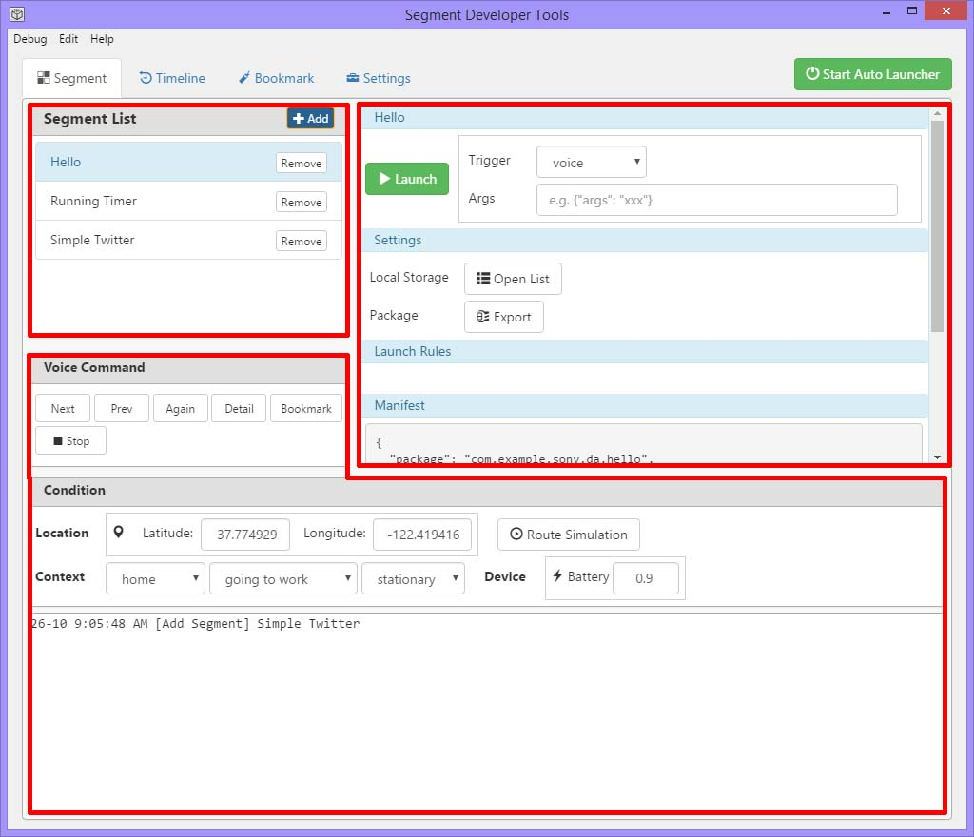

1. Select your new segment com.yourname.firstapp and click “Open”
2. Now that your segment is loaded click “Launch” to run your segment

**Step 4: Test your segment on the Concept N device**

[**https://developer.sony.com/develop/future-lab-program/n/test-and-verification/**](https://developer.sony.com/develop/future-lab-program/n/test-and-verification/)

1. Download the Concept N app to your android device :
   1. <https://play.google.com/store/apps/details?id=jp.co.sony.flp.n.companionapp>
2. Launch the app and walk through the tutorial to setup your Concept N device with your Android device. **Be sure to link your facebook account.**
3. In “Segment Developer Tools” click “Export”. A .cpk file will be created for you.
4. Now open up your online developer profile and **link your account to Facebook** (This is needed so that the Concept N app can link your test segment to your profile and allow you to see your segment on the Concept N app)
   1. https://developer.sony.com/develop/future-lab-program/n/n-developer-profile/
5. Click on “Upload applications” :
   1. <https://developer.sony.com/develop/future-lab-program/n/upload-n-application/>
6. From here click “Choose File” and select the .cpk you created in step 1 and click Upload.
7. Now restart the Concept N app on your Android device and you should see your segment in the segments list “(Debug) Hello”. Be sure that the checkbox next to the segment is selected
8. Now on the Concept N device Say “Listen up Nigel”. When it is in listening mode say “start simple hello”. The device should speak “Hello World”

At this point you are ready to create segments for Concept N.

Useful Links:

Main Concept N Site : <http://www.futurelab.sony.net/N>

Concept N Develoer Site : <https://developer.sony.com/develop/future-lab-program/n/>

Concept N API Reference : https://developer.sony.com/reference/segment-json-sdk/schemas